Covid Data: Report and Analysis

Dataset used
- country_wise_latest.csv
Contains global daily cumulative COVID-19 statistics over time, including confirmed cases, deaths, and recoveries.
It is mainly used to analyse global trends, compute daily changes, and derive monthly CFR and recovery rates.

- day_wise.csv
This dataset is useful for cross-country comparisons and identifying most affected countries at a specific time.

- full_grouped.csv
Includes daily COVID-19 data grouped by country, with confirmed, deaths, recovered, and active cases. It enables time-series analysis at the country level, such as tracking national outbreaks and comparing trends between countries.

- worldometer_data.csv
Summarises country-level COVID-19 statistics reported by Worldometer, including cases, deaths, recoveries, tests, and population indicators and is useful for high-level comparisons, mapping, and understanding the relative burden across countries.

- 2019.csv
Represents pre-pandemic baseline data from 2019, often used as a reference or comparison period. It helps contextualise COVID-19 impacts by comparing pre-COVID conditions with pandemic-period data.

Summary Statistics
- full_grouped.csv: Country Specific Summary Statistics
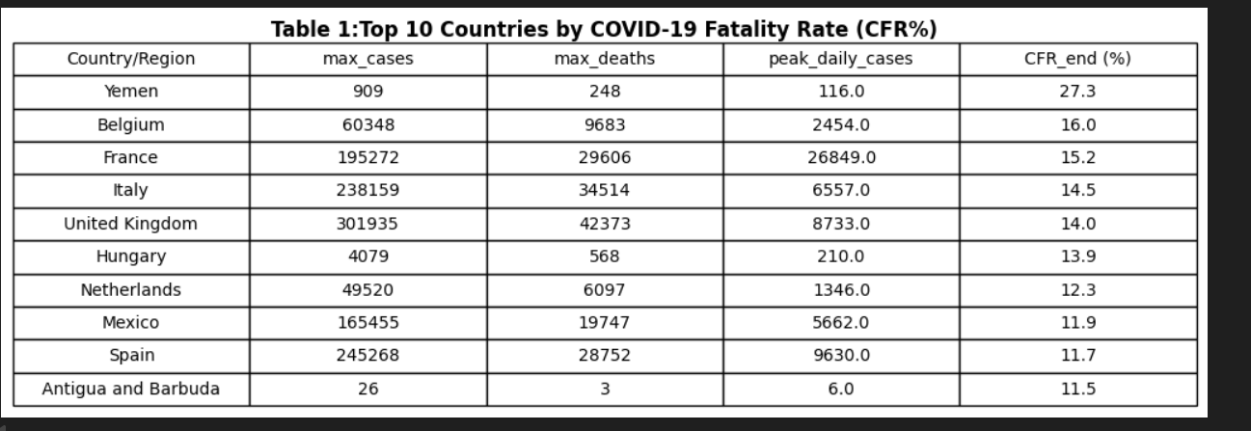
Figure 1Top 10 countries by CFR%
Yemen has the highest COVID-19 fatality rate (27.3%), likely due to limited healthcare resources. High mortality rates in European countries during peak times emphasize the need to consider testing coverage and healthcare capability when evaluating CFRs, which can be inflated in countries with low case counts, like Antigua and Barbuda.
- day_wise.csv: Monthly Global Summary Statistics of CFR and recovery rates
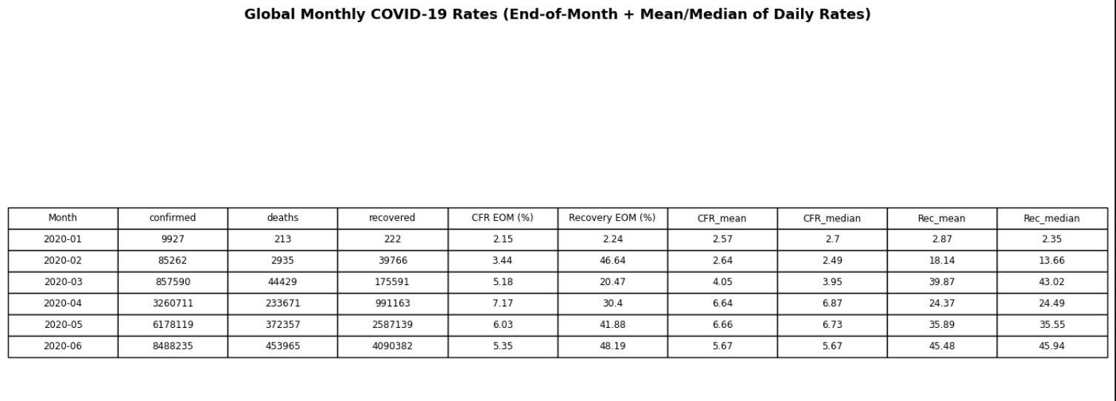
Figure 2 Monthly CFR and recovery %
The global CFR peaked at ≈7.2% between January and April 2020, representing the early severity of the pandemic, and subsequently decreased, showing better reporting and management. With steady monthly rates and few outliers, recovery rates increased dramatically from March. The CFR declined after April, demonstrating improvements in clinical management and reporting.

Storyline

Confirmed Corona cases vs Corona Deaths
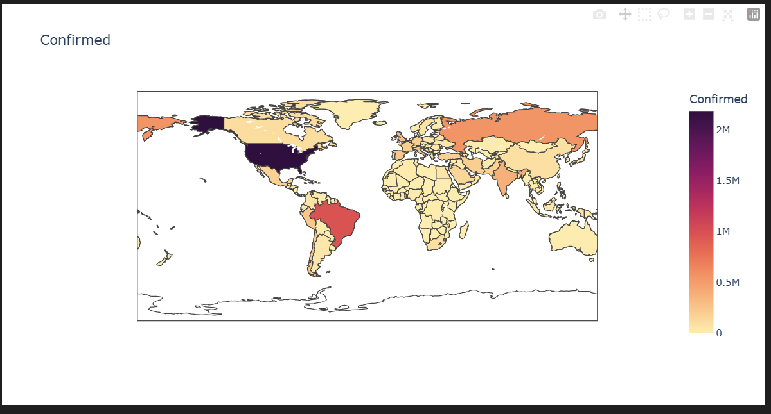
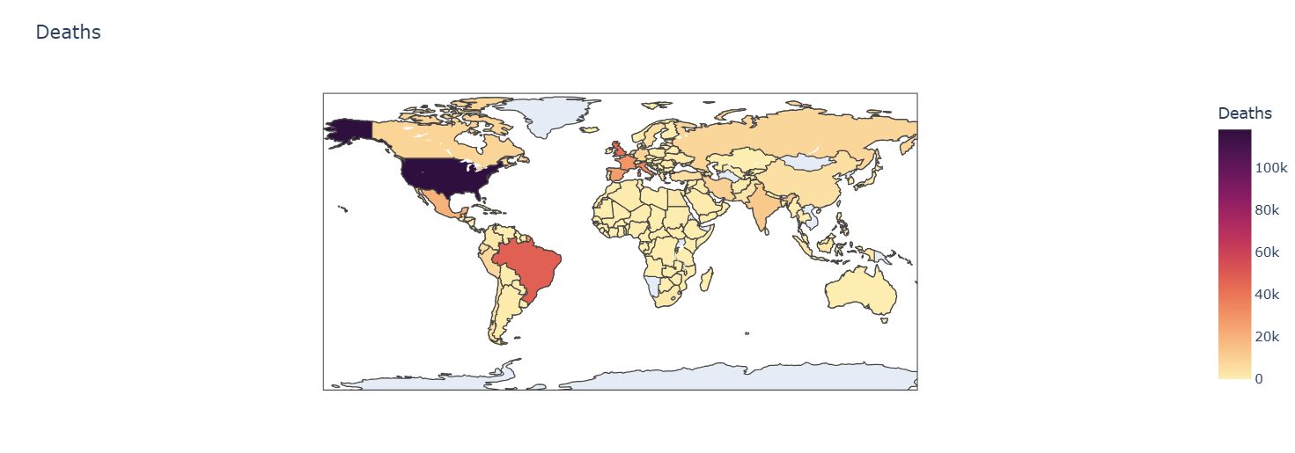
Figure 3 Comparison of Confirmed cased and Death cases
Maps show that nations with the highest number of COVID-19 cases—most notably the United States and Brazil—also record the highest number of fatalities, indicating global transmission and inconsistent healthcare effectiveness. While darker hotspots indicate substantial healthcare burdens, certain places exhibit high cases with fewer mortality, suggesting factors like younger populations or better management.

Comparison between New Cases and New Deaths for the Top 5 countries
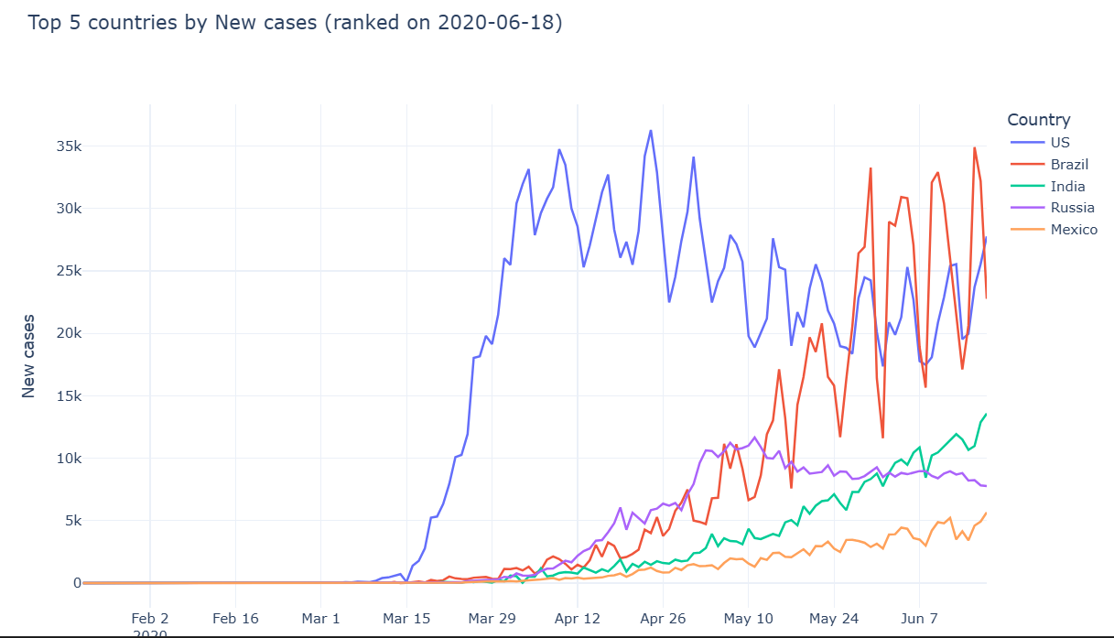
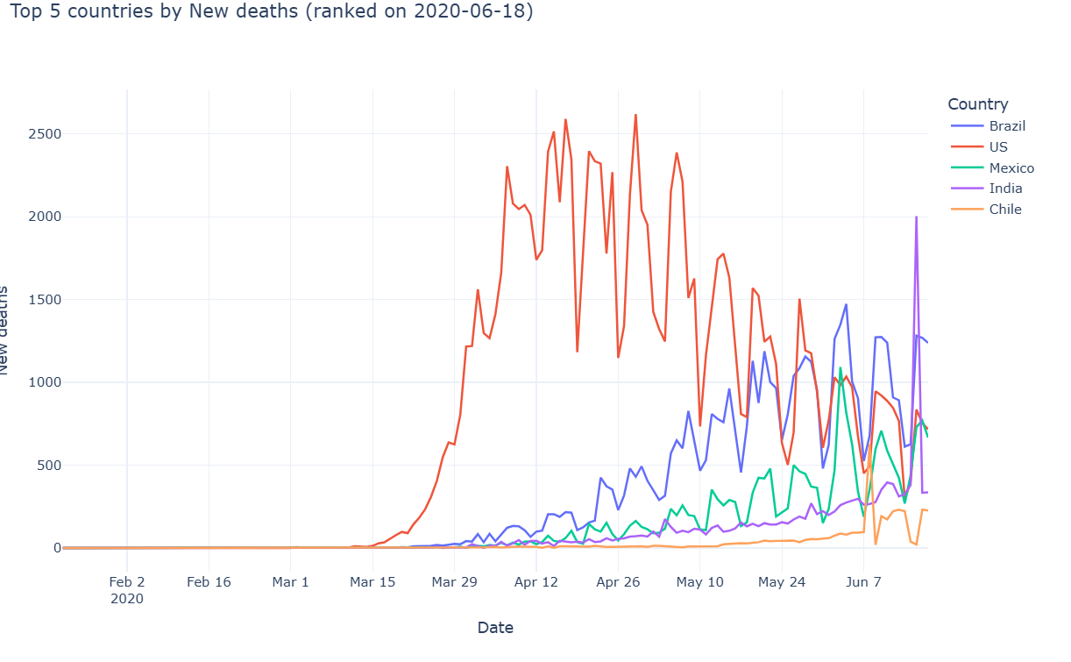
Figure 4 Comparison between New Cases and New Deaths for the Top 5 countries
According to the plots, the United States experienced the first and greatest increase in COVID-19 cases and fatalities between April and May of 2020, showing broad transmission prior to control measures. The pandemic's epicenter shifted to emerging economies, as seen by the subsequent sharp surges in Brazil and India. Globally, the number of new cases climbed dramatically, but the number of deaths increased more slowly and unevenly, indicating improved clinical care and diagnostics.

Comparison between New Cases and Recovery Cases for the Top 5 countries

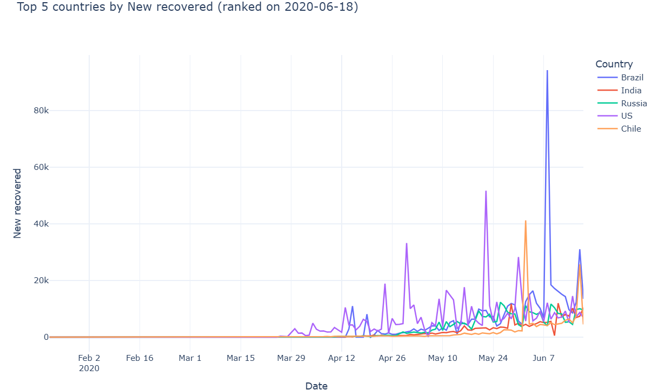
Figure 5 Comparison between New Cases and Recovery Cases for the Top 5 countries
The U.S. had the earliest and largest surge in COVID-19 cases, peaking in April, while Brazil and India later showed significant increases, indicating a geographic shift in the pandemic. Russia and Mexico experienced moderate, sustained rises. Recoveries lag new cases, with spikes in Brazil and the U.S. likely due to reporting changes rather than improvements. This contrast emphasizes the time lag between infection and recovery and differences in national reporting practices.

Relationship between confirmed cases and deaths
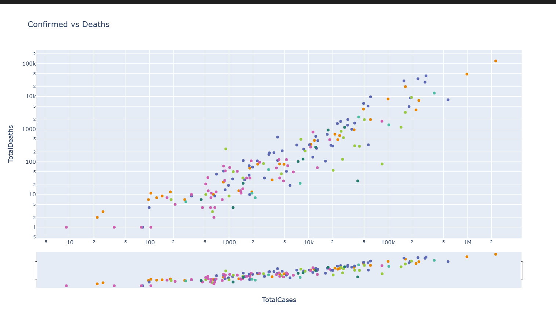
Figure 6 Relationship between confirmed cases and deaths
There is a definite rising trend: the number of deaths typically rises in tandem with the number of verified cases. A roughly proportionate relationship is indicated by most 156 data points clustering along a diagonal line. Some nations, however, deviate from this pattern, indicating higher or lower percentages of case fatalities. The plot illustrates how healthcare systems, reporting accuracy, demographics, and other regional characteristics affect fatality outcomes, even though more cases usually result in more fatalities.

Cumulative Fatality Rate (Deaths/Confirmed) over time
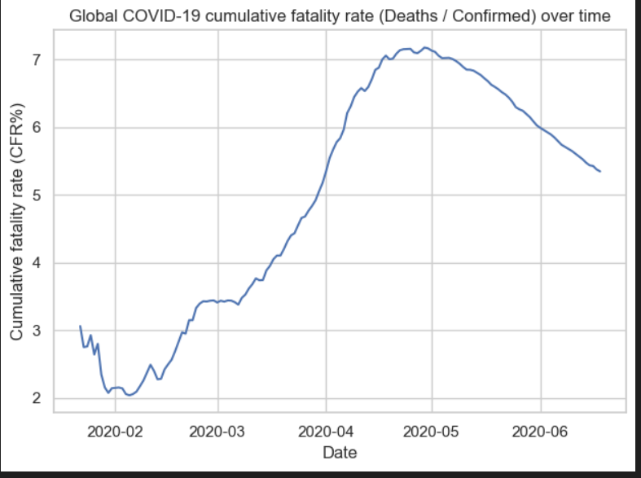
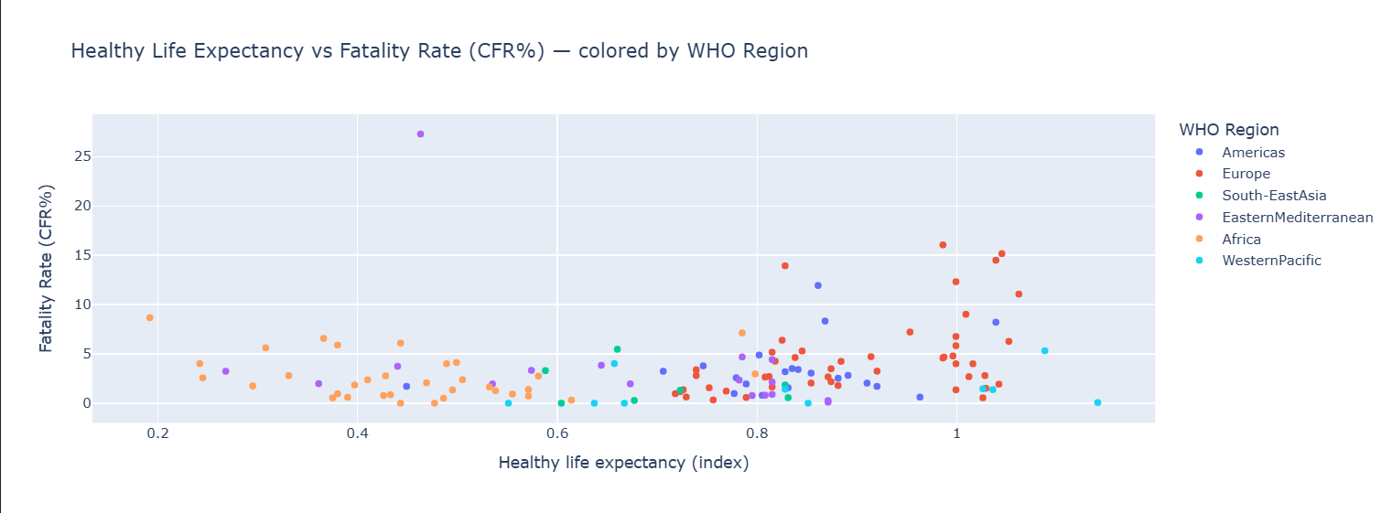
Figure 7 CFR trend and relationship between life expectancy and CFR
The first graph, which illustrates better diagnostics and medical solutions, shows the global COVID-19 cumulative fatality rate (CFR%) climbing from 3% in early 2020 to over 7% in mid-April before falling to 5.5% by June. The second picture highlights the impact of age distribution and healthcare systems by comparing life expectancy and CFRs by nation. It shows no discernible pattern, but greater CFRs are observed in countries with lower life expectancies, especially in Africa.

Pandemic Spread Rate
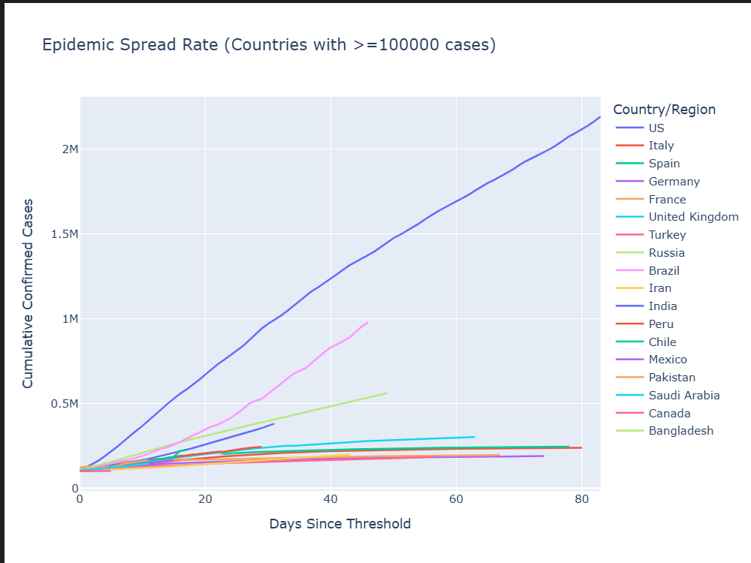
Figure 8 Pandemic Spread Rate
The line graph illustrates COVID-19 spread rates in countries with over 100,000 cases, plotting days since the threshold. The U.S. (blue line) has the steepest curve, indicating the fastest spread, with over 2 million cases in under 80 days. Brazil, Russia, and India also show notable growth, while Italy, Germany, and Spain indicate improved management after initial rapid expansion. This highlights significant variations in spread rates across countries.

